DS LAB P1

A university wants to automate their admission process. Students are admitted based on the marks scored in a

qualifying exam.

A student is identified by student id, age and marks in qualifying exam. Data are valid, if:

● Age is greater than 20

● Marks is between 0 and 100 (both inclusive)

A student qualifies for admission, if

● Age and marks are valid and

● Marks is 65 or more

Write a program to represent the students seeking admission in the university.

**WRITTEN SOFTCOPY:**

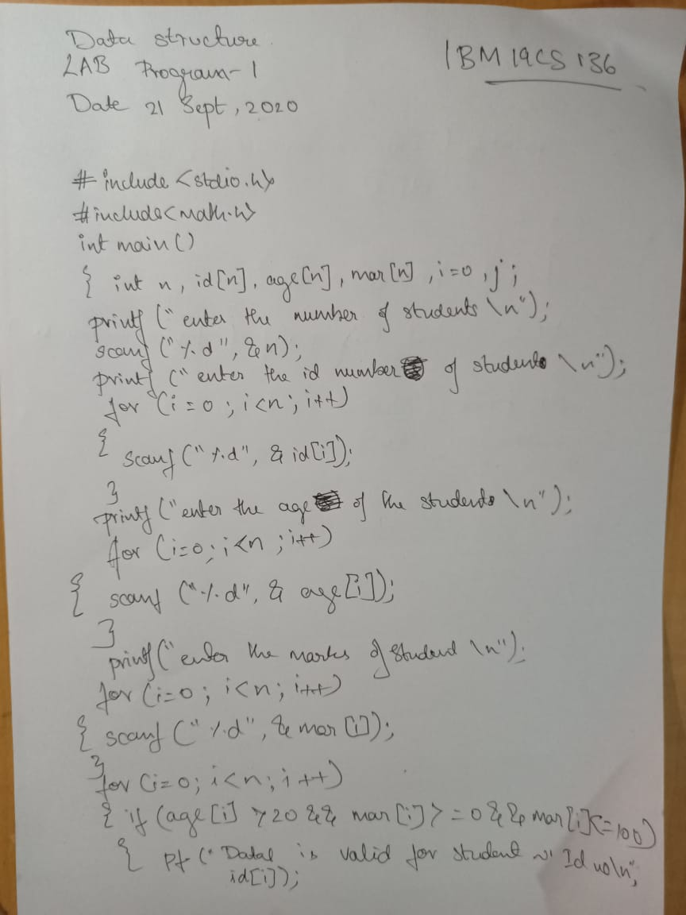

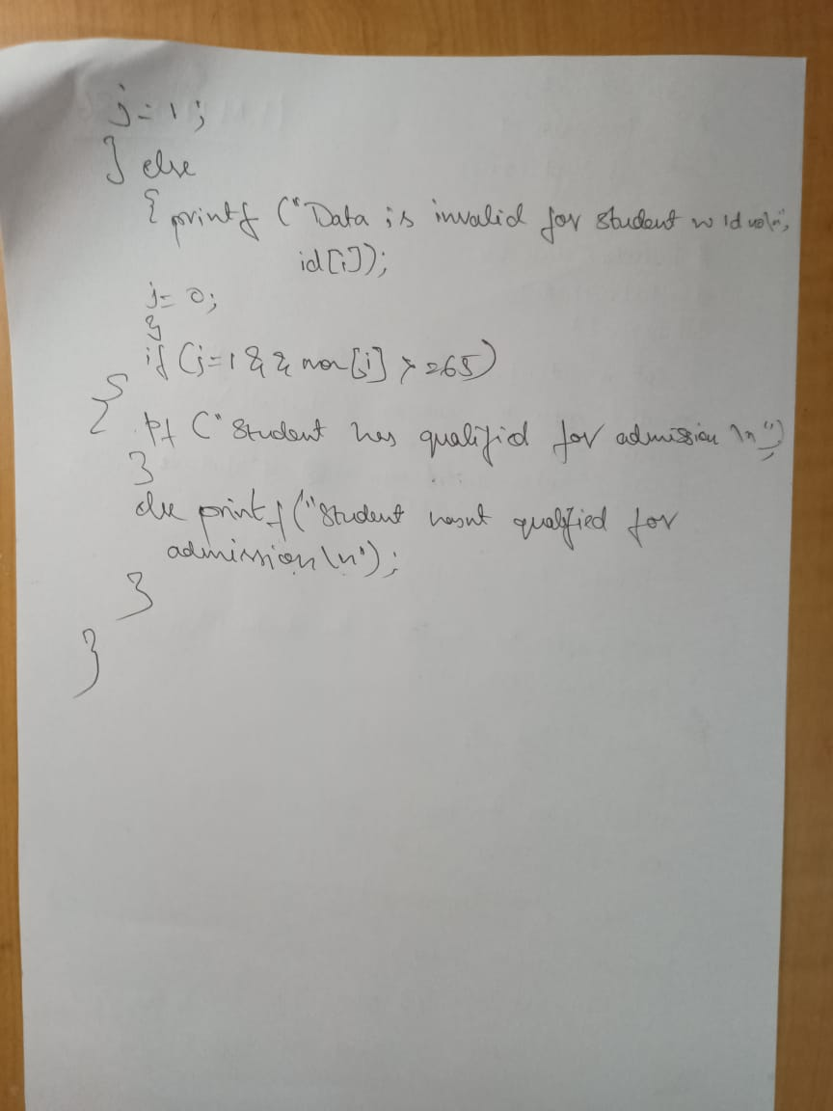

**CODE:**

#include <stdio.h>

#include <math.h>

int main()

{

int n, id[n], age[n], mar[n],i=0,j;

printf("enter the number of students\n");

scanf("%d",&n);

printf("enter the id number(s) of student(s)\n");

for(i=0;i<n;i++)

{

scanf("%d", &id[i]);

}

printf("enter the age(s) of the student(s)\n");

for(i=0;i<n;i++)

{

scanf("%d",&age[i]);

}

printf("enter the marks of student(s)\n");

for(i=0;i<n;i++)

{

scanf("%d", &mar[i]);

}

for(i=0;i<n;i++)

{

if(age[i]>20&&mar[i]>=0&&mar[i]<=100)

{

printf("Data is valid for student with id number %d \n", id[i]);

j=1;

} else

{

printf("Data is invalid for student with id number %d \n", id[i]);

j=0;

}

if(j=1&&mar[i]>=65)

{

printf("Student has qualified for admission\n");

}

else printf("Student has not qualified for admission\n");

}

}

OUTPUT:

